**STRATHMORE LECTURE ROOM RESOURCE MANAGEMENT SYSTEM**

**Admission Number: 071392**

**IS project documentation submitted to the Faculty of Information Technology in partial fulfillment for the requirement of the degree of Bachelor of Business Information Technology of Strathmore University**

**Date of Submission: March 2016**

# Declaration

I declare that this work has never been submitted for examination in any university

Admission No:………………………. Signature:……………….. Date:………………………..

I certify that this work is being submitted for examination with my approval

Supervisor’s Signature:…………………………………… Date:……………………………….

# Abstract

Lecture room resource management has been a prevalent issue in major leading Kenyan universities. This is due to the complexities involved in striking a balance between assigning of rooms in an economic manner and ensuring room availability at any point in time during the school’s operational hours. This project aims at providing efficiency in lecture room resource management in Strathmore University. This process involved interviewing of faculty administrators, lecturers as well as students given they will be the key benefactors of the system. A brief review of the current system being used is also done in order to point out the specific areas that have been improved on and those which have been enhanced to bring out a better product for the intended users. One of the key outcomes of the development process is a fully functional lecture room resource management system which is essentially a web based application integrated with a database.

Contents

Declaration ii

Abstract iii

List of Tables v

List of Figures vi

Abbreviations and Definition of terms vii

Chapter One: Introduction 1

1.1 Background 1

1.2 Problem Statement 2

1.3 General Objective 3

1.3.1 Specific Objectives 3

1.4 Justification 3

1.5 Scope 4

Chapter Two: Literature Review 5

2.0 Introduction 5

2.1 Components of Lecture Room Resource Management Systems 5

2.2 MySQL Database Management System 5

Table 2-1: Merits and Demerits of Common Relational Database Management Systems 7

Chapter Three: Methodology 8

3.1 Introduction 8

3.2 System Analysis 8

3.2.1 Functional Requirements 8

3.2.2 Non Functional Requirements 9

3.2.3 System Analysis Techniques 9

3.3 System Design 10

3.4 System Development Tools and Techniques 10

3.4.1 System Development Tools 10

3.4.2 System Development Techniques 10

3.5 Deliverables 11

Chapter Four: System Analysis and Design 12

4.1 Introduction 12

4.2 System Analysis 12

4.3 System Design 13

Chapter Five: System Development, implementation and Testing 21

5.1. Introduction 21

5.2. System development 21

5.3. System Implementation 22

5.4. System testing 22

Chapter Six: Conclusion 24

6.1. Conclusion 24

6.2. Recommendation 24

6.3. Future Work 24

References 26

Appendix 27

Appendix A: Time Schedule 27

Appendix B: Questionnaire 28

# List of Tables

Table 2-1: Merits and Demerits of Common Relational Database Management Systems…………….7

# List of Figures

Figure 1 Entity Relationship Diagram 14

Figure 2 Database Schema 15

Figure 3 Class Diagram 16

Figure 4 Administrator Sequence Diagram 17

Figure 5 Lecturer Sequence Diagram 18

Figure 6 Student Sequence Diagram 19

Figure 7 Use Case Diagram 20

# Abbreviations and Definition of terms

**1. SQL:** Sequential Query Language: This is a special-purpose programming language designed for managing data held in a relational database management system (RDBMS), or for stream processing in a relational data stream management system (RDSMS).

**2. DBMS:** Database Management System: This is a computer software application that interacts with the user, other applications, and the database itself to capture and analyze data.

**3. RDBMS:** Relational Database Management System: This is a database management system (DBMS) that is based on the relational models invented by E. F. Codd, of IBM's San Jose Research Laboratory.

**4. TCO:** Total Cost of Ownership: This is a financial estimate intended to help buyers and owners determine the direct and indirect costs of a product or system.

**5. API:** Application Programming Interface: is a set of routines, protocols, and tools for building software and applications.

**6. DFD:** Data Flow Diagram:  This is a graphical representation of the "flow" of data through an information system, modelling its process aspects.

**7. UML:** Unified Modeling Language: This is a general-purpose, developmental, modeling language in the field of software engineering that is intended to provide a standard way to visualize the design of a system.

**8. MD5:** Media Digest 5: This is a widely used cryptographic hash function producing a 128-bit (16-byte) hash value, typically expressed in text format as a 32 digit hexadecimal number. MD5 has been utilized in a wide variety of cryptographic applications, and is also commonly used to verify data integrity.

**9. CSV**: Comma-Separated Values: This type of file stores tabular data (numbers and text) in plain text. Each line of the file is a data record. Each record consists of one or more fields, separated by commas. The use of the comma as a field separator is the source of the name for this file format.

# Chapter One: Introduction

## 1.1 Background

A university is an institution that offers higher learning and grants academic degrees in various fields of study. The typical setting of an average university involves a physical geographical area composed of buildings housing rooms utilized for lectures, financial operations, administration and other related activities. Included in this setting is an important constituent – a community of scholars and teachers, which is the rough translation of the Latin phrase *universitas magistrorum et scholarium,* from which the term “university” is derived. An idea fostered in the concept of a university is academic freedom. This is whereby students are at liberty to choose a field of study of their own preference as offered by the particular university.

Strathmore University started in 1961 as the first multi-racial college (http://www.strathmore.edu/en/about-strathmore/history). Awarded with a letter of interim authority to operate as a university in 2002, there are currently over 4000 students enrolled in Strathmore University (full-time and part-time) studying Accountancy, Law, Administration, Commerce, Finance, Management and Information Technology. Over 70 lecture rooms are at the campus’ disposal mainly for lecturing purposes. In addition to these, students have access to over 10 labs fully equipped with computers.

With the numerous number of students enrolled, lecture rooms comprise one of the scarce resources that need to be managed efficiently to ensure economical operation of the teaching process as well as preventing congestion of rooms. This is done using an academic timetable which is published every academic year for the various courses offered by the university at different intake periods. The successful manner in which the university administration develops the timetables serve 4 vital functions:

1. Notifying students of the venues of lecture sessions for the various units they are undertaking,
2. Giving students a visual and mental perspective of how a particular day is planned out as far as lecture sessions are concerned,
3. Ensuring that there are no time conflicts in regard to lecture sessions and
4. Ensuring the efficient utilization of the campus’ lecture rooms.

The last function is a key focus area in the developed system. Efficient utilization of lecture rooms in the campus prevents the wastage of lecture rooms which is manifested in there being little periods of time where a given lecture room is not in use. Despite this being a show of efficiency on the administration’s part, it creates a problem both for the lecturer and the student that will be discussed below.

## 1.2 Problem Statement

On a daily basis, a full time student in Strathmore University usually has a significant number of free hours accumulated from the distributed mid-lecture intervals. Most of this time is spent at the university library, the student center, in a vacant lecture room or outside the campus. In cases where a student intends on spending this “idle” time in a vacant lecture room – which is usually the case – identifying the room in the first place proves to be a big challenge. This involves physically checking room by room to see if a lecture session is ongoing. This process consumes a lot of time which could otherwise be used in doing something more constructive. Other than time wastage on the student’s part, this process is also a distraction to participants of an ongoing class as other students repeatedly check about the rooms. The proposed system will be able to mitigate this by giving students on-the-go access of information pertaining vacancy of rooms in the campus at any given time. This will significantly save a lot of time and simultaneously ensure a vacant room is put in to good use by efficiently connecting the resource to the one needing it.

During a lecture session, lecturers may occasionally be dissatisfied with the room specifications due to one factor or another including capacity, personal preference, acoustics etc. Should this be the case, the lecturer proceeds to contact the administration who is able to assign the lecturer a different room should it be available. Though effective in most cases, this process is unnecessarily lengthy and wastes time that could otherwise be used in delivering the learning material to the students. The proposed system will enable lecturers and class representatives alike to immediately retrieve information on rooms that are vacant and enable them to reserve them remotely in real time right from their mobile device or computer. This would result in a notification to any other user concerning the reservation made.

All these will enable the university as a whole increase its productivity and spend more time doing what it is intended to do – advance knowledge.

## 1.3 General Objective

The main aim objective of this system is creating a platform for Strathmore University students, lecturers and faculty administrators to better view and manage the lecture rooms as a resource which mainly includes capability to easily reserve rooms as well have an instant view of vacant rooms in the campus at any given time for the users’ convenience. All these functions will be conveniently available to the user through any web browser.

### 1.3.1 Specific Objectives

1. To identify key components of a Lecture Room Resource Management System.
2. To review MySQL database management system which will be used in the partial development of the system.
3. To implement a Lecture Room Management System.
4. To test the system’s functionality.

## 1.4 Justification

The Lecture room management system used currently by the university (<http://timetable.strathmore.edu/>) does not implement the functionality of allowing students to have an instant view of the campus’ vacant lecture rooms at a given point in time. An implementation of a system that has this capability would be of high value to empower the average Strathmore University student.

Despite, having room reservation functionality, this can only be done with intervention from the different faculty administrators i.e. a given lecturer cannot conveniently reserve a vacant room without consulting the administrator. The proposed system will enable this function to be done directly by the lecturer.

The third advantage that the system has over the current one is on the accessibility of functionality. Being a web based application, users can access the system ideally wherever they are given there is internet access. This is a major aspect of the system as it will significantly increase effectiveness of students and lecturers alike in utilizing the campus’ resources economically and productively.

The final crucial characteristic of the system focuses on simplicity. The current system in use in very complex and difficult to interpret the information displayed pertaining the campus’ lecture rooms. The proposed system will focus on user-friendliness to enable any student or lecturer to utilize the functionality of the system and to enable them to easily interpret data displayed.

## 1.5 Scope

The proposed system is limited to offer the services to fulltime students i.e. it will display daily information on the campus’ lecture rooms between 8.15 a.m. and 5.15 p.m. The reason for this is the continuous nature of evening classes done by part time students in relation to the main aim of the developed system. Since a part time student has only one class at any given day in school, they do not experience “idle time” in between classes for that given day i.e. there are no mid-lecture intervals. The system would thus be ideally impractical in their case and implementation of a similar functionality for evening classes would not be economical.

Administration privileges which include vacant room reservation and engaged room clearance (e.g. in cases of cancelled classes) is limited to university lecturers, class representatives and faculty administrators. Other users will only be allowed a “read-only” mode of access.

# Chapter Two: Literature Review

## 2.0 Introduction

This chapter will give a summary of the current state of lecture room resource management systems. Its main aim is to identify and explain concepts specific to components used in the development of the system. A literature review is a summary of a subject field that supports the identification of specific research questions – it distills the existing literature in a subject field; its objective is to summarize the state of the art in that subject field (J Rowley, 2004).

A lecture room resource management system is a tool that allows a user to construct schedules for a group of individuals in a learning institution (Marie, 2006). It strives to coordinate four elements – students, lecturers, rooms and time slots.

The following are some of the advantages of lecture room resource management systems:

Elimination of paper-based processes

The use of a lecture room resource management system eliminates the need of using paper based processes that may create bulk. Record keeping is thus made more efficient and cost effective with the added benefit of IT technology integration.

Intuitive and user friendly

The lecture room resource management system provides a simple user interface thus an indiscernible learning curve. This assures that the intended users may spend less time figuring out how to use the system and utilizing more time to actually use the system.

Generation of multiple timetables

The lecture room resource management system allows for seamless generation of timetable visualization which would otherwise be time consuming and prone to error without such a system.

Flexibility

A lecture room resource management system allows a privileged user to make modifications where possible with the only restrictions being access to the Internet. Elimination of

Highly secure

Optimal resource allocation

Substitution management

Easy integration

## 2.1 Components of Lecture Room Resource Management Systems

To enable security of a Lecture Room Resource Management System, access control is implemented by use of a log in module that prompts users for a pre-defined username and password. These parameters, should they be authorized, allow a user to access the system as well as identify the type of privileges they have. In the proposed system, access control will be in the criteria of faculty administrator, lecturer, and student, each having a set of unique privileges.

Other components of a Lecture Room Resource Management System are as follows:

1. Database:  This is a collection of information that is organized so that it can easily be accessed, managed, and updated. In one view, databases can be classified according to types of content: bibliographic, full-text, numeric, and images. (Rouse, 2010)
2. Remote Server Connection: The database will be hosted on a remotely accessible server.
3. Web application: This is an application in which all or some parts of the software are downloaded from the Web each time it is run. It may refer to browser-based apps that run within the user's Web browser, or to "rich client" desktop apps that do not use a browser or to mobile apps that access the Web for additional information. (web applications, 2015).
4. Access List Controllers: This component will be used in user privilege management in the system.

## 2.2 MySQL Database Management System

A database management system (DBMS) is a collection of programs that enables you to store, modify, and extract information from a database (Vangie, 2010). MySQL is an open source database management system that uses Structured Query Language (SQL) for extracting database information and is one of the leading relational database management systems commonly used by businesses (Giacomo, 2005).

Other common Relational Database Management Systems (RDBMS) used include PostgreSQL, Oracle, MS SQL Server and Informix. Illustrated below is a general comparison of these RDBMs’ advantages and drawbacks.

### Table 2-1: Merits and Demerits of Common Relational Database Management Systems

|  |  |  |
| --- | --- | --- |
| **RDBMS** | **Advantages** | **Drawbacks** |
| Oracle | Versatile, stable, and secure | Potentially high Total Cost of Ownership(TCO) |
| MS SQL Server | Stable and secure; Microsoft offers excellent support | Relatively high TCO; proprietary. |
| PostgreSQL | Up-and-coming database with low TCO | Has yet to be widely implemented in large-scale business use. |
| Informix | Stable; has good support available. | Generally higher TCO |
| MySQL | Offers a best-case-scenario database in many ways; low TCO; high stability; high security and excellent support. | Not all available versions can offer the full range of MySQL capabilities. |

MySQL is the Relational Database Management System that was used in the system.

# Chapter Three: Methodology

## 3.1 Introduction

Methodology is the systematic and theoretical analysis of different methods applied in a particular area of study (Hice, 1978). Thus system development methodology in software engineering is a framework that is used to structure, plan, and control the process of developing an information system. There are several methodologies used in system development. The common ones include Waterfall Model, Agile Software Development and Rational Unified Process (RUP). System developers implement different model based on a number of pertinent factors that may make one methodology more suitable compare to another given the parameters.

For the development of the new system, the Waterfall Model was applied. The Waterfall Model, also referred to as the Traditional Model, is a system development methodology that uses a number of defined phases that are implemented sequentially (Petersen, 2009). This approach was applied in the development of the system as it is convenient in determining progress as well as being able to accurately estimate the time required to complete system development. This model thus allowed prudent time budgeting to be done pertaining to the development phases.

## 3.2 System Analysis

System analysis is the process of decomposing a system into its component pieces for the purpose of the studying how well those component parts work and interact to accomplish their purpose (Blanchard, 1990). For this to be done effectively, an analysis of functional and nonfunctional requirements have to be clearly defined.

### 3.2.1 Functional Requirements

1. Access control
   1. The system is able to ensure access level privileges are strictly compartmentalized with regards to the end user’s position. This is implemented by a login module that determines privileges bases on “hierarchy” level. This ensures no unauthorized personnel operates a level-specific restricted operation hence security.
2. Output
   1. The system is able to display information requested by a user which is retrieved from the database.
3. Input
   1. The system allows authorized users to issue controls that create user generated data to be stored in the database accordingly.
4. Remote access
   1. The system allows remote access to the server where the database resides.

### 3.2.2 Non Functional Requirements

1. Security
   1. The system ensures only authorized users can access the system’s services.
2. Accessibility
   1. Access to the service is always available given one has internet access.
3. Simplicity
   1. The graphics user interface ensures ease of use of the system.
4. Reliability
   1. The information stored in the database provides real time data thus the information is be highly reliable and of value to the user

### 3.2.3 System Analysis Techniques

1. Observation
   1. Observation was done to enable reviewing of the shortcomings of the current system and to enable determination of the best way to mitigate them in the new system.
2. Questionnaires
   1. These were issued to the new system’s benefactors to be able to get more input on how to best suit the system for the users’ utility. This can be found in the Appendix section.
3. Use- Case
   1. This is a list of actions that define what each actor that will participate in the system will be able to do while depicting the various interactions with other users and different processes. The new system comprises of the following actors:
      1. Administrator
      2. Lecturer
      3. Class representative
      4. Student

## 3.3 System Design

Systems design is the process of defining the [architecture](https://en.wikipedia.org/wiki/Systems_architecture), components, modules, interfaces, and [data](https://en.wikipedia.org/wiki/Data) for a [system](https://en.wikipedia.org/wiki/System) to satisfy specified [requirements](https://en.wikipedia.org/wiki/Requirement).

The following are system design types that will be used in the development of the proposed system:

1. Data Flow Diagram (DFD)
2. Entity Relationship Diagram
3. Database Schema
4. Class Diagram
5. UML Use Case Diagram
6. Sequence Diagrams

## 3.4 System Development Tools and Techniques

### 3.4.1 System Development Tools

The following system development tools were used:

1. Sublime Text
   1. Sublime Text is a [cross-platform](https://en.wikipedia.org/wiki/Cross-platform) [source code editor](https://en.wikipedia.org/wiki/Source_code_editor) with a [Python](https://en.wikipedia.org/wiki/Python_(programming_language)) [application programming interface](https://en.wikipedia.org/wiki/Application_programming_interface) (API). It natively supports many [programming languages](https://en.wikipedia.org/wiki/Programming_languages) and [markup languages](https://en.wikipedia.org/wiki/Markup_languages), and its functionality can be extended by users with [plugins](https://en.wikipedia.org/wiki/Plugins), typically community-built and maintained under [free-software licenses](https://en.wikipedia.org/wiki/Free_software_licenses).
2. Phpmyadmin
   1. Consisting of MySQL database manipulation tools, this tool was mainly used for the construction of the database.
3. Apache
   1. This open source web server application was used to host the web application during development.

### 3.4.2 System Development Techniques

Modelling was implemented in the development of the system. Modellingproduces a graphical representation of a concept or process that systems developers can analyse, test and modify.

## 3.5 Deliverables

The following are deliverables produced at the end of the system development:

1. System
   1. This is the functional system itself – a Lecture Room Resource Management System.
2. User manual
   1. This provides user oriented assistance on details concerning the functionality of the system and how to use it.
3. Documentation of the system
   1. A detailed document pertaining various aspects of the system.

# Chapter Four: System Analysis and Design

## 4.1 Introduction

The main aim objective of developing this system was to create a platform for Strathmore University students, lecturers and faculty administrators to better view and manage the lecture rooms as a resource which mainly includes capability to easily reserve rooms as well have an instant view of vacant rooms in the campus at any given time for the users’ convenience. This objective was to be met by the development of a minimalistic simple web application that has these basic functionalities.

Another objective that was to be met was ensuring of access control by the criteria of type of users i.e. student, class representative, lecturer or administrator. This is to ensure only authorized personnel have the capability of performing certain high-level operations such as adding and removal of user profiles. This was accomplished in the new system by use of authentication techniques such as use of MD5 password encryption and effective session management.

On the objective of ensuring UI simplicity, the system uses a minimalistic user interfaces that manages to get the job done with the least amount of extraneous information that tends to complicate most systems.

Reliability and availability of the system is ensured by providing low network overhead due to the simple design thus ensuring that information is always available to the intended users as long as there is access to the Internet.

## 4.2 System Analysis

This section aims at logically describing the developed system as well as providing an illustration that will help in visualizing how the system provides its functionality.

The database will reside on a remote server together with the web server. phpmyadmin and MySql have been used in the construction of the database whereas Apache is used for the web service. The web server has access to the source code files which include php, html, css and csv files. When a user requires the system’s services, they simply use a web client to access the web server hosting the web application at which point they will be prompted for their credentials. The credentials provided are compared to the data existing in the database i.e. user identification and password pair. The user is authorized should the credentials match.

At this point the user has the minimum authority to view the classes ongoing at that particular time or at an arbitrary time set. This is made possible by comparing the given time to the information provided in the database pertaining the collection of timetables that dictate the schedules.

Lecturers and class representatives have the added option of reserving vacant rooms for specific periods of time. When this is done, other users accessing the application are able to see the change in the schedules/vacancies thus preventing conflicting reservations.

At the top of the hierarchy in terms of access control is the administrator. This user is able to add and remove other users to the system while defining their access privileges. They are responsible for updating of the timetable collection as well as nullifying reservations made when necessary.

These distinctions that enable seamless access control are made possible by session management where clients are assigned session identifications that distinguish between the three user levels.

Illustrated below in a depiction of the basic operation of the system:

WEB BROWSER

WEB SERVER

DATABASE

## 4.3 System Design

This section aims at giving a more detailed and illustrative depiction of the system. This gives the logical structure of the system by use of a number of modelling techniques prevalently UML. Different designs are given to illustrate the different aspects of the system including static views such as class diagrams and dynamic views such as sequence diagrams.

Illustrated below are the designs used in the development of the system:

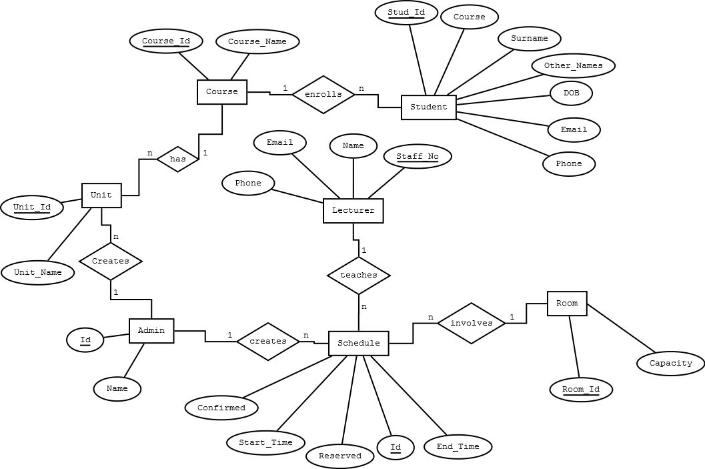

Figure 1 Entity Relationship Diagram

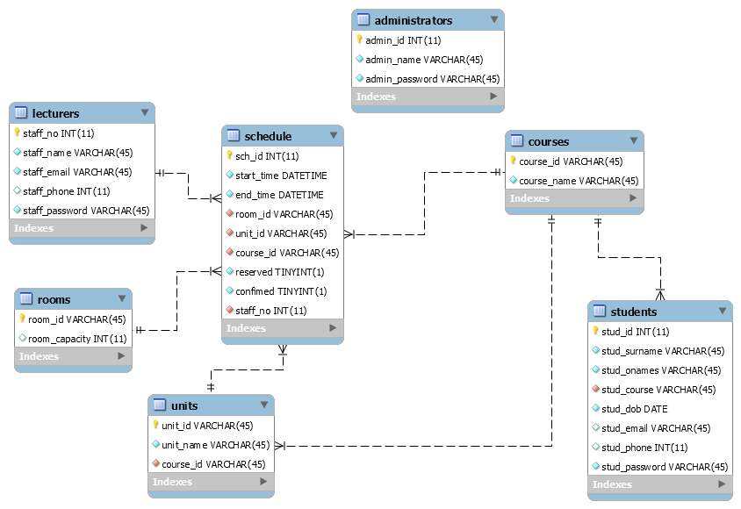

Figure 2 Database Schema

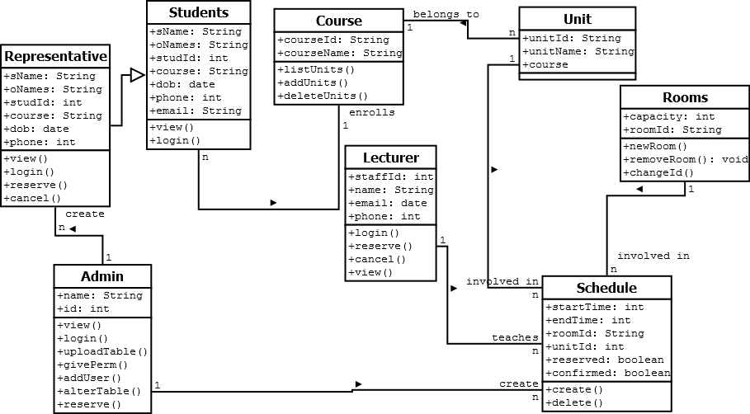

Figure 3 Class Diagram

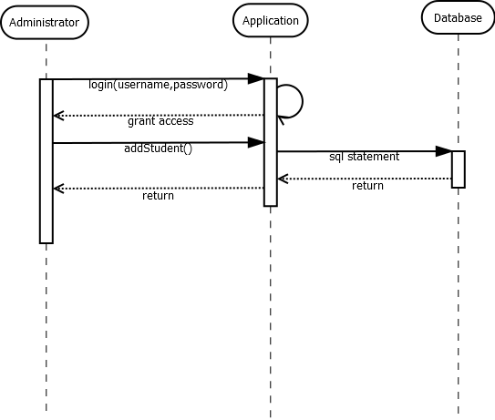

Figure 4 Administrator Sequence Diagram

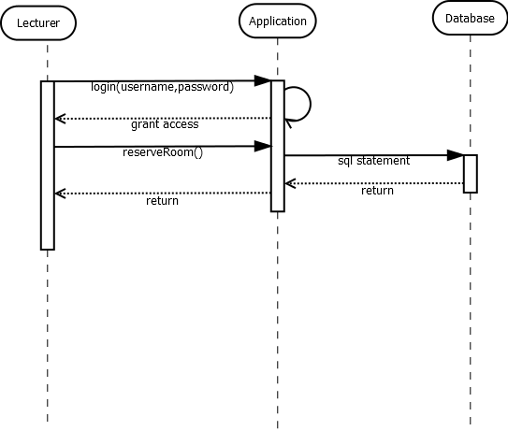

Figure 5 Lecturer Sequence Diagram

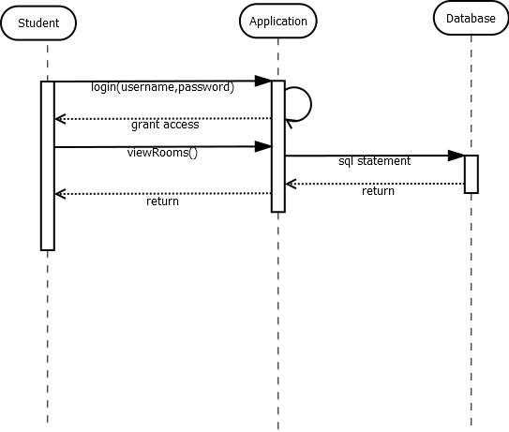

Figure 6 Student Sequence Diagram

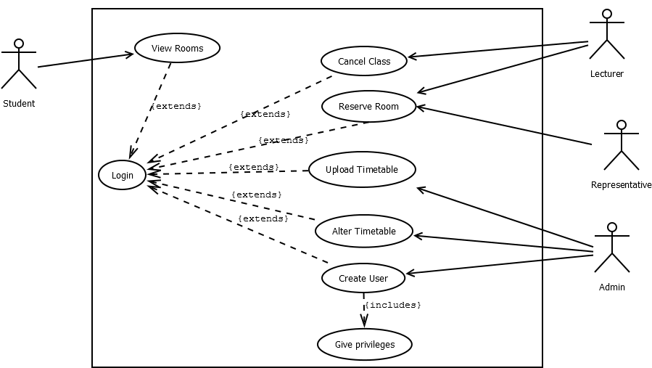

Figure 7 Use Case Diagram

# Chapter Five: System Development, implementation and Testing

## 5.1. Introduction

This section describes the main objective and shows how it was completed.

Development of the web application was done using Sublime Text which is a sophisticated text editor that can be used in place of an IDE. This was the preferred tool as its simple UI is easy to understand while it has visual cues that help in the coding process.

The Database was constructed using MySql and phpmyadmin as a frontend. These were preferably use as they are readily available free of charge as well as for their resilience and versatility.

## 5.2. System development

For the development of the new system, the Waterfall Model was applied. The Waterfall approach to systems analysis and design was the first established modern approach to building a system. This method was originally defined by Winston W. Royce in 1970. The Waterfall Model, also referred to as the Traditional Model, is a system development methodology that uses a number of defined phases that are implemented sequentially (Petersen, 2009). This approach was applied in the development of the system as it is convenient in determining progress as well as being able to accurately estimate the time required to complete system development. This model thus allowed prudent time budgeting to be done pertaining to the development phases.

The following were the following were the various stages in the system development process:

Requirements analysis

The Waterfall method makes the assumption that all requirements can be gathered up front during the **Requirements** phase (Hughey, n.d.). During this phase, the primary benefactors’ responses to the needs of an ideal system are solicited and added to the list of mandatory requirements of the system. Requirements analysis was done to establish that the system being developed will be of value.

Design

The Design phase is best described by breaking it up into Logical Design and Physical Design sub phases. During the Logical Design phase, the system's analysts makes use of the information collected in the Requirements phase to design the system independently of any hardware or software system (Hoffer, et al, 2008). In this stage, UML diagrams were constructed to represent the system’s functionality. These included class diagram, sequence diagrams, ERD and the database schema.

## 5.3. System Implementation

The Implementation phase is where all of the actual code is written ("SDLC Phases", n.d.). This section describes the manner in which the new system will be deployed and integrated in the intended users’ normal operations.

In this phase, the main activity done is programming of the code building the web application itself. Being a web application, the languages used prevalently are php and html as this is the conventional norm in web application development. Csv files were also used in simulating of timetable scenarios. Below is some php code snippet that allows checks on the schedules at a given time from the database:

print "The following classes are in session at this time(".$mytime.")";

$SQL="SELECT * FROM schedule WHERE start_time < '".$mytime."' AND end_time > '".$mytime."'";

$result=mysqli_query($db_handle,$SQL);

Some of the design reuse will be of the timetables as this system will only reflect what is already set by the school faculty administrators. The system will be implemented using incremental builds in that intermittent builds will be deployed to meet user needs when they arise after familiarization with the system.

Risk mitigation measures will also be implemented at this point should any be identified as some aspects may have been overlooked to provide user flexibility.

## 5.4. System testing

This phase was originally called for by Royce to ensure that the project is meeting customer expectations. This section describes the input done in ensuring the system functions as required. The main aspect that was being tested is security which is one of the most critical requirements of web applications. Other aspects include resilience, integrity and availability.

Test techniques that were used include the process of executing different modules of the application with the intent of finding software bugs (errors or other defects).

The technique used in this phase involved use any web client software to access the web application. This would subsequently be followed by attempting to log in to the system with unauthorized credentials to test the security of the system as far as access to the application is concerned. The main function is then tested which involved assuring that the system is able to display the required data on request e.g. checking if a given classroom is empty at the time set by the user.

The other aspect being tested other than security and functionality included user-friendliness. Primary benefactors were given the application to try utilize its functionality. This was a source for identifying errors in order to avoid numerous bugs in the final system.

# Chapter Six: Conclusion

This chapter gives a brief overview of the main objective that the system set out to achieve and how effectively it managed to accomplish it. It also aims at discussing what future development may be done on the system to improve on it whether on a functional or non-functional level. It also gives recommendations on the use of the system in order to be able to get the most out of it.

## 6.1. Conclusion

Using this new system, Strathmore lecturers and students will able to be more productive in their operations. This system is able to gives lecturers a platform for reserving vacant rooms thus saving time that would otherwise be used in middle-man consultation visa vis the faculty administrators by the lecturers. The system also gives students the utility of getting information on which rooms are vacant in the campus on the fly. This saves time for students thus allowing them to put more time in productive activities.

The system is also simple and easy to learn thus the benefactors will experience user friendliness with the application. Being a web application, the system’s services will always be available to any user as long as they have access to the Internet. Abiding by strong security procedures, the system ensures data confidentiality, integrity and authentication thus users can be comfortable that the system will be highly reliable.

## 6.2. Recommendation

The main objective has been met by striving to find out the needs of the intended beneficiaries and putting their suggestions into account during the development of the system. This system will be highly beneficial to Strathmore University lecturers and students as well as the administration of the school as a whole.

## 6.3. Future Work

This section describes some of the shortcomings of the new system as well as areas where improvement could be made to increase its utility.

Automation of timetable integration with the schedules in the database will significantly increase the efficiency of the system as it will avail administrators a platform to more effectively provide the system’s functionality to other users.

Some other work that could be done on the system is improvement of the user interface to improve on visual appeal. Focus on minimalism and simplicity may come at a cost of aesthetic quality and user feedback can be used as an indication on the visual appeal of the new system which can be adjusted accordingly to fit their need.

# References

1. Rowley, J., & Slack, F. (2004). CONDUCTING A LITERATURE REVIEW. *Management Research News*, *27*(6), 31-39.
2. Giacomo, M. D. (2005). MySQL: Lessons learned on a digital library. *Software, IEEE*, *22*(3), 10-13.
3. MySQL, A. B. (2001). MySQL.
4. Hice, G. F. (1978). System development methodology. *Amsterdam: North-Holland, 1978, rev. ed., edited by Turner, WS; Cashwell, LF*, *1*.
5. Callaos, N., & Callaos, B. (1991). A Systemic definition of Methodology. In *35th Annual Meeting of the International*.
6. Petersen, K., Wohlin, C., & Baca, D. (2009). The waterfall model in large-scale development. In *Product-focused software process improvement* (pp. 386-400). Springer Berlin Heidelberg.
7. Blanchard, B. S., Fabrycky, W. J., & Fabrycky, W. J. (1990). *Systems engineering and analysis* (Vol. 4). Englewood Cliffs, New Jersey: Prentice Hall.
8. Hoffer, Jeffrey A.; George, Joey F.; Valacich, Joseph S. (2008). *Modern Systems Analysis and Design.*Upper Saddle River, New Jersey: Pearson Education, Inc.
9. e-digg.com. (n.d.). *SDLC Phases*. Retreived from <http://www.e-digg.com/services/software/sdlc-life-cycle.html>
10. Hughey, D. A. (n.d.). *Comparing Traditional Systems Analysis and Design with Agile Methodologies*. Retrieved from UMSL: <http://www.umsl.edu/~hugheyd/is6840/introduction.html>
11. Rouse, M. (2010). *SearchSqlServer*. Retrieved from TechTarget: http://searchsqlserver.techtarget.com/definition/database
12. *web applications*. (2015). Retrieved from PCMag: http://www.pcmag.com/encyclopedia/term/54272/web-application

# Appendix

## Appendix A: Time Schedule

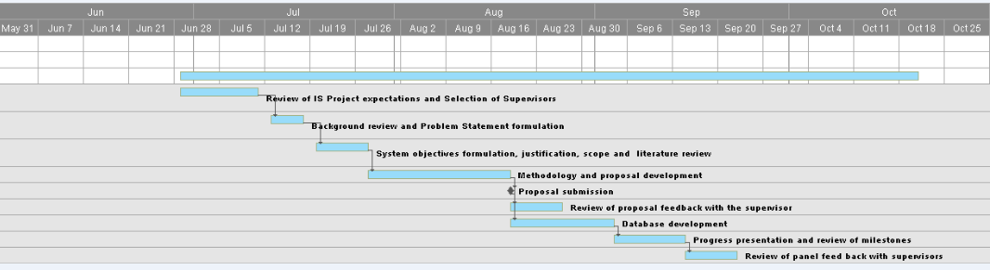

## Appendix B: Questionnaire

The following is a questionnaire to gather information on effectiveness of lecture room resource management in Strathmore University.

Please tick as appropriate:

|  |  |  |  |
| --- | --- | --- | --- |
|  | Agree | Neutral | Disagree |
| The university has enough rooms for its operations |  |  |  |
| I mostly spend my free time in vacant classes |  |  |  |
| Rooms are available when I do not have a class |  |  |  |
| Finding a room during my free time is simple |  |  |  |
| Reserving a room is a simple exercise |  |  |  |
| Changing class venues is simple |  |  |  |
| Thank you for your time. Feel free to leave any additional comments: | | | |